Task 11: Phishing Attack Simulation & Detection
1.Understand phishing attacks
- Phishing is a type of social engineering attack where attackers impersonate trusted entities.
- It is commonly carried out using emails, SMS, or fake websites.
- The attacker tricks users into clicking malicious links or entering sensitive information.
- Common targets include usernames, passwords, bank details, and OTPs.
- Phishing attacks exploit human psychology such as fear, urgency, or curiosity.
- Even secure systems can be compromised if users fall for phishing emails.
- Phishing is one of the most common cyber attacks used today.
Common Types of Phishing Attacks
Email Phishing
- Fake emails with malicious links or attachments.
- Most common phishing method.
Spear Phishing
- Targeted phishing aimed at a specific individual or organization.
Clone Phishing
- A legitimate email is copied and modified with a malicious link.
Smishing
- Phishing via SMS messages.
Vishing
- Phishing through phone calls pretending to be banks or support teams.

2.Create fake email template
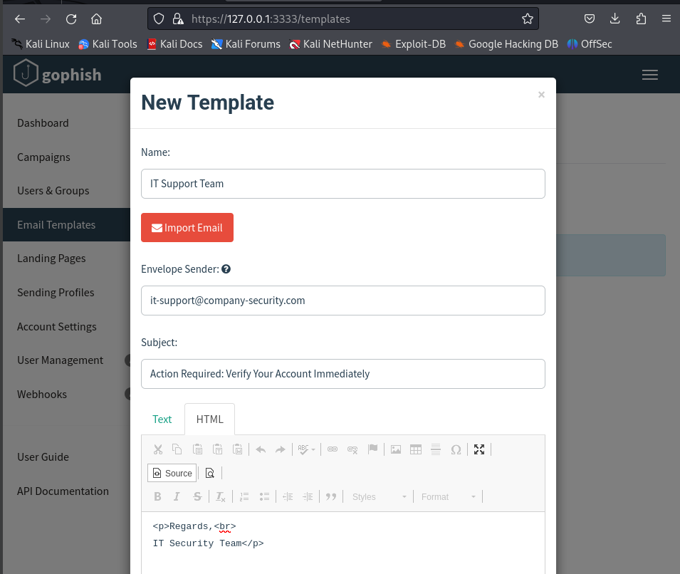
3.Setup landing page.
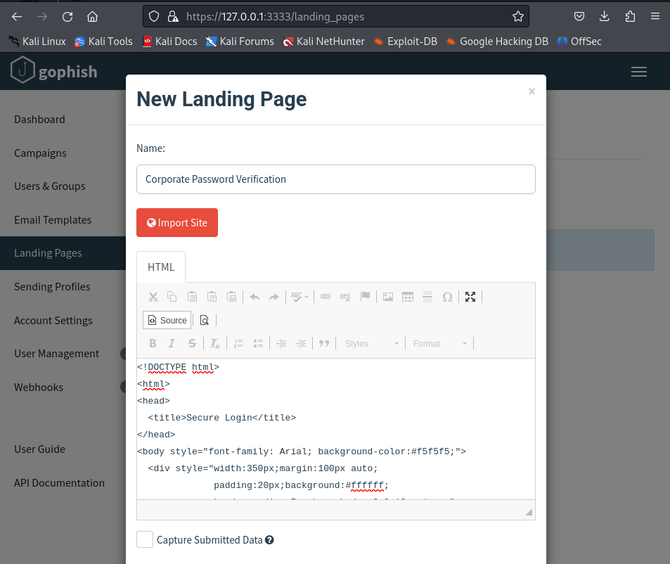

4.Send test phishing email
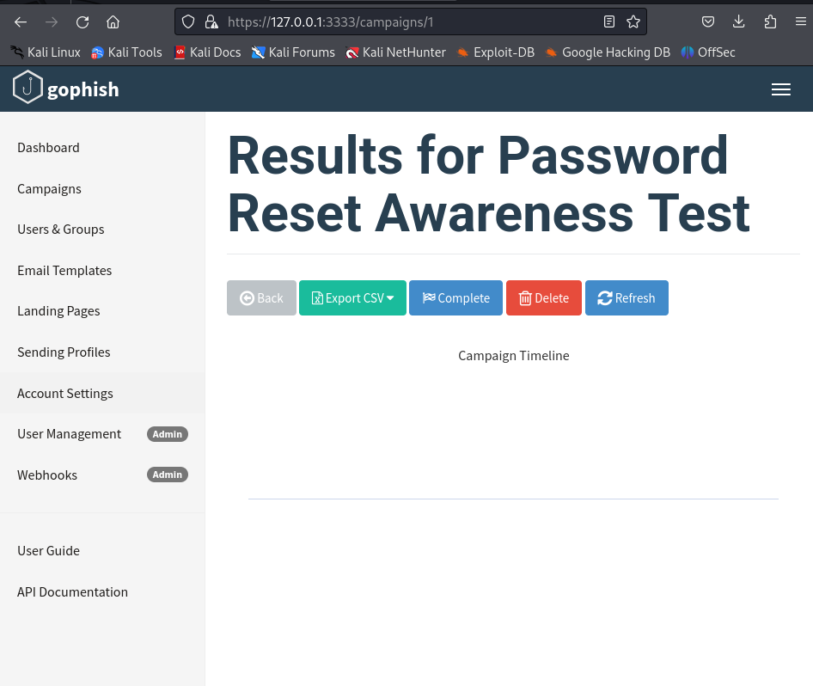

5.Track responses
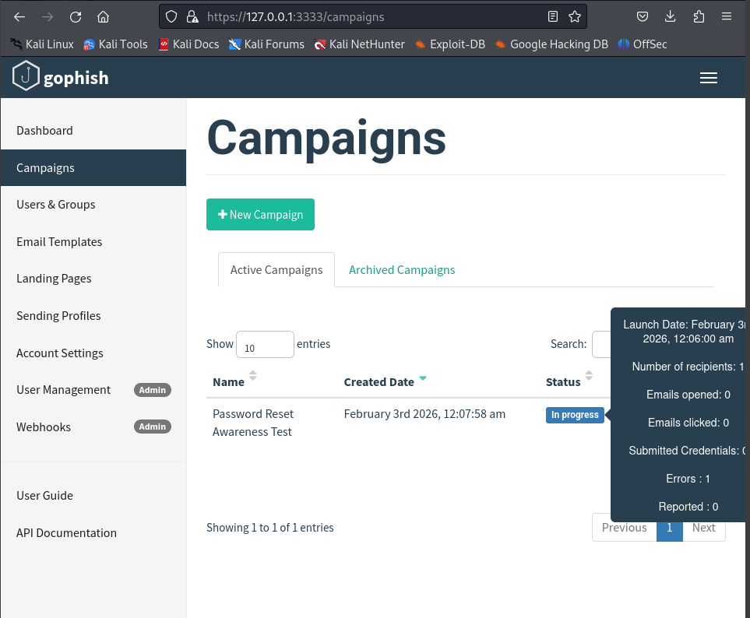

6.Identify red flags
- Generic greeting – used “Dear User” instead of the recipient’s real name
- Urgent message – claimed the account would be restricted if not verified
- Suspicious link – link redirected to a fake login page (not the real website)
- Request for credentials – asked the user to enter username and password
- Sender mismatch – email address looked official but was not from the real domain

7.Learn prevention.
- User awareness training
Teach users to identify fake emails, suspicious links, and urgent messages.
- Verify sender details
Always check the email address and domain before clicking links or replying.
- Avoid clicking unknown links
Hover over links to see the real URL before opening them.
- Use email security filters
Spam filters and anti-phishing tools help block malicious emails.
- Enable multi-factor authentication (MFA)
Even if credentials are stolen, MFA prevents account compromise.
- Do not share credentials via email
Legitimate organizations never ask for passwords through emails.

Conclusion
This phishing attack simulation demonstrated how attackers exploit human trust using deceptive emails and fake landing pages. The exercise highlighted how easily users can fall victim to social engineering attacks if proper awareness is lacking. By analyzing user responses and identifying phishing red flags, this task emphasized the importance of user education, email security controls, and cautious online behavior. Overall, the simulation improved understanding of phishing techniques and reinforced the need for strong preventive measures to protect against social engineering attacks.

